Input File

img= imread('OrangeBuilding.jpg');

Data = impixel(img);
img= im2double(Data);

[ CovaianceMatrix MatlabCov MeanVector Data ] = colorFeatures_HW04_PiterGarcia(img);

function [ CovaianceMatrix MatlabCov MeanVector Data ] = colorFeatures_HW04_PiterGarcia(img)

%%MatlabCov
MatlabCov= cov(img)

mr = mean(img(:,1))
mg = mean(img(:,2))
mb = mean(img(:,3))

%CovaianceMatrix
CovaianceMatrix = MatlabCov

%display(ConvaianceMatrix);
mrr = sum(img(:,1).*img(:,1))/2;
mgg = sum(img(:,1).*img(:,2))/2;
mbb = sum(img(:,1).*img(:,3))/2;

%MeanVector
MeanVector = [ mr mg mb]
%meanVector = [ mrr mgg mbb]

Data = img

% Save your 'my_results' matrix in file 'data_out.txt'
%save data_out.txt -ascii mrgb
end
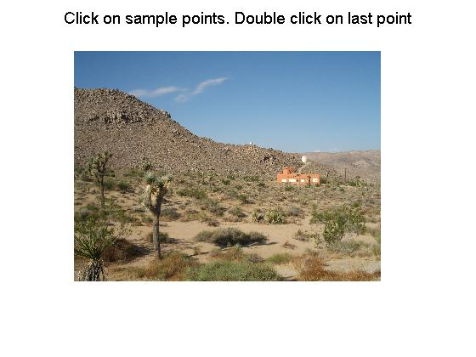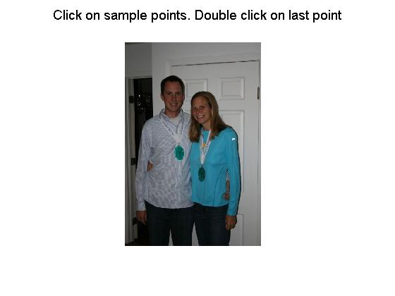
In this step I wrote a function to get first pixels input by the user, then mean values of the image as well as a vector of mean values. Also, return the matrices of the pixels, mean values vector and the calculated coverance matrix.
This step I proceed to ask the user to click on the pixels the user wishes to, and to click double click to finish once the user has picked the pixels.

function [EDMap EMapThreshImage imE MDMap MMapThreshImage imM ] = colorsegment_HW04_PiterGarcia(img)

img=imread(img);
img= im2double(img);

figure,
hold on
suptitle('Click on sample points. Double click on last point');
p=impixel(img)
%display('Click on sample points. Double click on last point');
prompt={'Enter threshold value for Euclidean segmentation:','Enter threshold value for Mahalanobis segmentation:'};
% Create all your text fields with the questions specified by the variable prompt.

[ CovaianceMatrix MatlabCov MeanVector Data ] = colorFeatures_HW04_PiterGarcia(p)
%imshow(img);

EMapThreshImage = sqrt( (img(:,:,1)-MeanVector(1,1)).^2 + (img(:,:,2)-MeanVector(1,2)).^2 + (img(:,:,3)-MeanVector(1,3)).^2 );
imshow(EMapThreshImage);
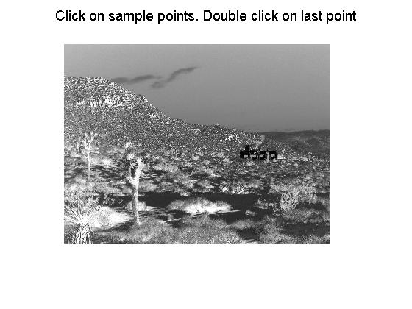
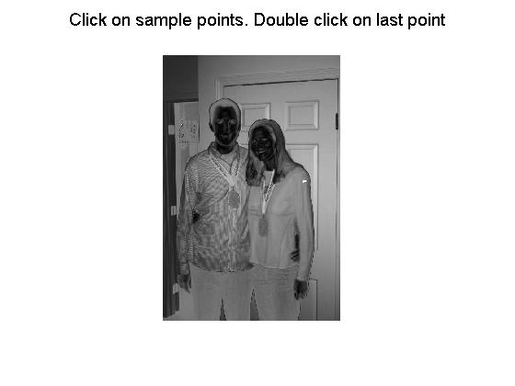

In this step I created another function that calls the first function. This functions main idea is to compute the Euclidean distanace as well as the Mahalanobis distance. The pictures you see above are the pictures generated after the Euclidean segmentation was performed, as you see the pixels pickes, which in this case were the faces and the house, have been emphasized in dark gray scale level.

%title('Distance Measure')
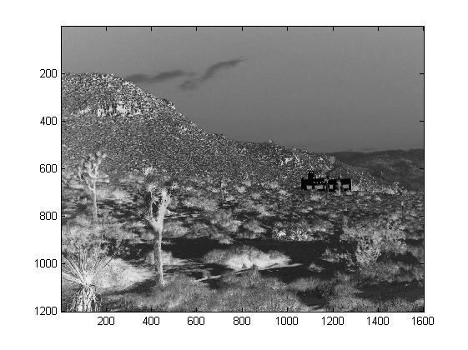
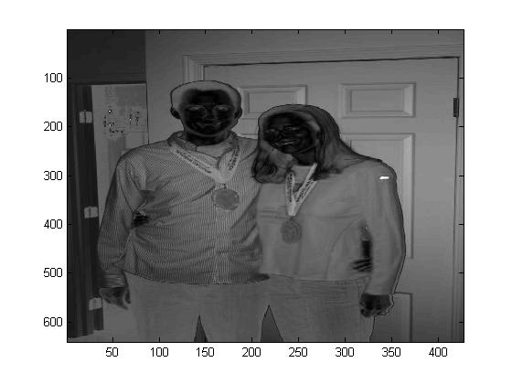
figure, imagesc(EMapThreshImage),colormap(gray),
The pictures you see above are the pictures generated after the Euclidean segmentation was performed, as you see the pixels picked, which in this case were the faces and the house, have been emphasized in dark gray scale level as shown.

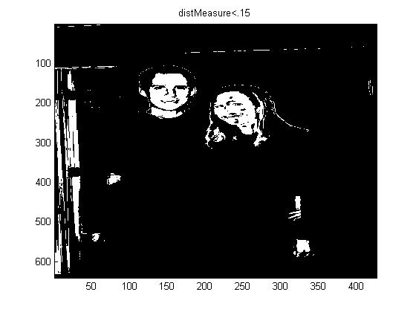
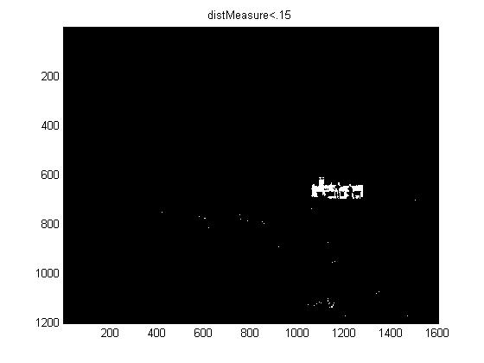
figure, imagesc(EMapThreshImage<.15), colormap(gray), title('distMeasure<.15');

The pictures you see above are the pictures generated after the Mahalanobis distance segmentation was simulated, as you see the pixels picked, which in this case were the faces and the house, have been emphasized in white scale level as shown. Pixels are been threshold to less that .15.

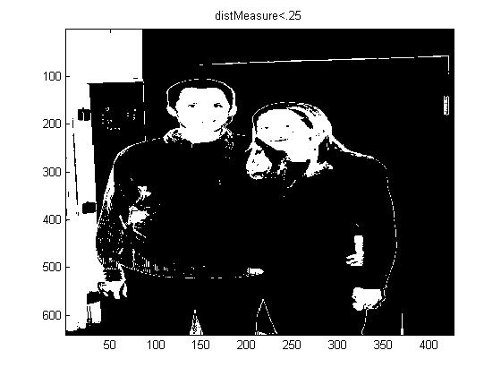
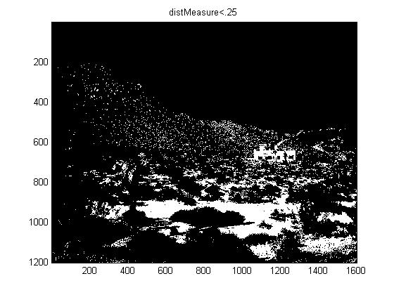
figure, imagesc(EMapThreshImage<.25), colormap(gray), title('distMeasure<.25');
The pictures you see above are the pictures generated after the Mahalanobis distance segmentation was simulated in black and white scale. This time we are thresholding the pixels picked to values les than .25.

%title('Distance Measure')
figure, imagesc(EMapThreshImage<.15), colormap, title('distMeasure<.15');
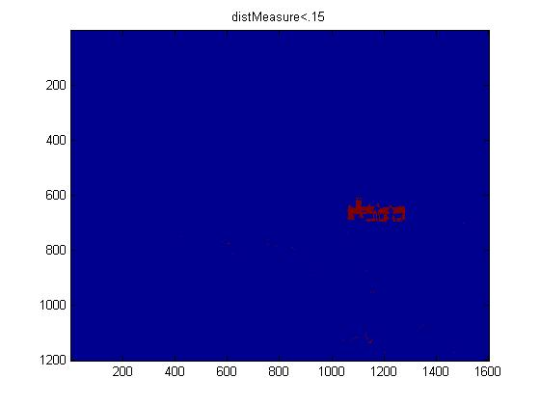
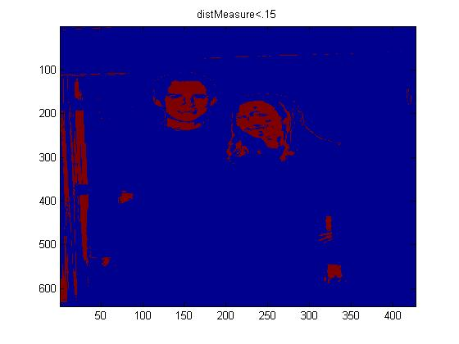

The pictures you see above are the pictures generated after the Mahalanobis distance segmentation was simulated in a color scale. This time we are thresholding the pixels picked to values les than .25.

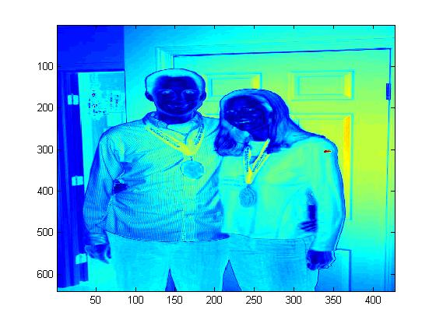
figure, imagesc(EMapThreshImage),colormap,
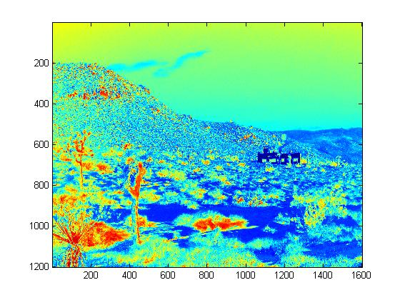
These pictures were generated after increasing the threshold in a color scale. Pixels picked by the user are being emphasized as sown above.

figure, imagesc(EMapThreshImage<.25), colormap, title('distMeasure<.25');
% Taken data from user.
answer=inputdlg(prompt,'Threshold values');
display('Enter threshold value for Euclidean segmentation on Screen');
T1 = str2num(answer{1});
display('Enter threshold value for Mahalanobis segmentation on Screen');
T2 = str2num(answer{2});
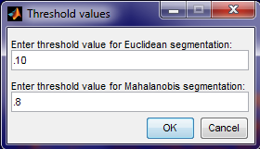
This window above is an example of how I am taking data from the user to assign to the variable the values the user wishes to use to threshold pixels picked for Euclidean and Mahalanobis distance segmentation.

%title('Distance Measure')
figure, imagesc(EMapThreshImage<T1), colormap(gray), title('Gray Scale ColorMap1');
figure, imagesc(EMapThreshImage<T2), colormap(gray), title('Gray Scale ColorMap2');
Displaying color and gray scale of the image generated by the threshold value input from the user as explained above.

%title('Distance Measure')
figure, imagesc(EMapThreshImage<T1), colormap, title('ColorMap1');
figure, imagesc(EMapThreshImage<T2), colormap, title('ColorMap2');
%title('Distance Measure')
EDMap = imagesc(EMapThreshImage),colormap,
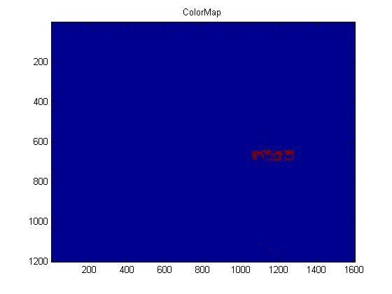
MDMap = imagesc(EMapThreshImage),colormap(gray),
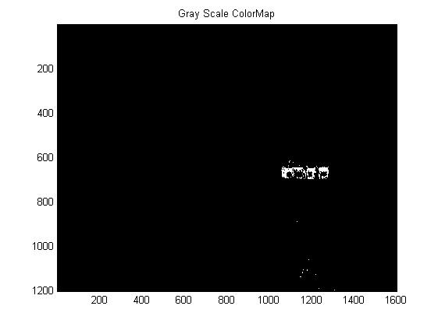

MMapThreshImage = imagesc(EMapThreshImage<.15), colormap(gray);
EMapThreshImage = imagesc(EMapThreshImage<.25), colormap(gray);

%title('Distance Measure')
imE = imagesc(EMapThreshImage<.15), colormap;
imM = imagesc(EMapThreshImage<.25), colormap;
end
Saving data as well as pictures to be returned.

Output
>> colorsegment_HW04_PiterGarcia('Orangebuilding.jpg')
p =
0.9333 0.6314 0.4275
0.9686 0.6784 0.4863
This is the data obtained from the second function. The pixels data picked by the user as well as the mean values, coverance, and vector of mean values obtained also by calling the first function through the second function as requested.
0.7176 0.5882 0.3882
0.5686 0.4392 0.2706

MatlabCov =
0.0355 0.0185 0.0163
0.0185 0.0107 0.0094
0.0163 0.0094 0.0083

mr=
0.7971
Mg=
0.5843
mb =
0.3931

MeanVector =
0.7971 0.5843 0.3931

Data =
0.9333 0.6314 0.4275
0.9686 0.6784 0.4863
0.7176 0.5882 0.3882
0.5686 0.4392 0.2706

CovaianceMatrix =
0.0355 0.0185 0.0163
0.0185 0.0107 0.0094
0.0163 0.0094 0.0083

MatlabCov =
0.0355 0.0185 0.0163
0.0185 0.0107 0.0094
0.0163 0.0094 0.0083

MeanVector =
0.7971 0.5843 0.3931

Data =
0.9333 0.6314 0.4275
0.9686 0.6784 0.4863
0.7176 0.5882 0.3882
0.5686 0.4392 0.2706

EDMap =
1.2150e+003

MDMap =
This is the data obtained from the second function. Data to be returned through the second function.
1.2120e+003

MMapThreshImage =
1.2140e+003

EMapThreshImage =
1.2120e+003

imE =
1.2140e+003

imM =
1.2120e+003

ans =
1.2150e+003

>>

Write Up

In this project two functions were built to perform different type of Matlab functions and implementations to analyze and understand coverance, mean values’ vector as well as the Euclidean and Mahalanobis distance segmentation.

Fisrt function: this function is used to get the matrix of the coverance. Also, the mean values of the image being processed as well as a vector of the mean values. In this function, calculation is used to get the mean value of each read, green blue and the matrix of the coverance.

Second function: this function first called the second function, once image is processed and pixels are selected by user, to obtain the above matrixes of the image and pixels selected by the user. Afterword, the data obtained is used to implement the Euclidean calculation to obtain the distance segmentation between pixels with the matrixes obtained from the image through the first function. Another, after the image is obtained from the previous implementation different threshold values are assigned to the image to compare. Similarly, it is done with the Mahalanobis implementation. I use the same approach to simulate the Mahalanobis distance segmentation process. After the image is obtained from the previous implementation different threshold values are assigned to the image to compare.

Third, different threshold values are asked to be input by the user. Once these values are input these are used to threshold the image in different scale and with different distance segmentation process to compare different outputs.

Comparison: images obtained from different methods the Euclidean and Mahalanobis distance segmentation process emphasized pixels selected in its own unique way. Judging from the obtained images by doing the Euclidean distance transformation we can say the following. The pixels picked from the image were made darker while the whole rest of the pixels were made more cleared in a gray scale. This means values obtained from the selected pixels were increased by the transformation while the others pixels were decreased in order for us to focused on the selected area.


Example:
In the same way, Mahalanobis distance transformation works in a similar manner in the sense that it also emphasizes the selected pixels but in a different way. This means, that the pixels selected values are decreased while all other pixels are increased in order to put more emphasis on the selected region of the picture.


Example:

